Pie Chart (Note: The examples below are with Windows Vista)

- Open Survey Data file (a link to the file is in the “Sampling Distribution of Sample Proportions – QZ20” part of the prepare section in Unit 3 in Brain Honey).

- With the survey data, copy the ENTIRE column B (Gender Column) data and paste that column and paste that column in a separate spreadsheet (To get the entire column B, click on the top of the column, where the “B” is.)

- In a cell to the right of the gender data, the words “Female” and “Male” (one on top of the other.

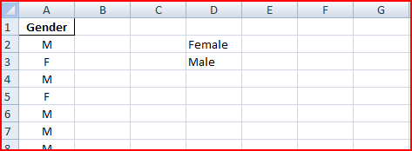

- In the cell to the right of the “Female” cell, type in the following function: =COUNTIF(A:A,"F")

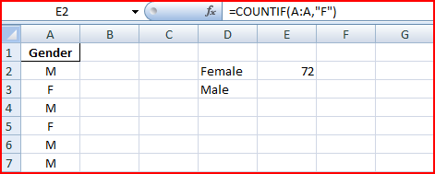

- In the cell to the right of the “Male” cell, type in the following function: =COUNTIF(A:A,"M")

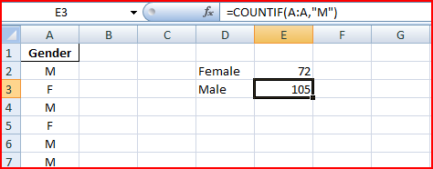

- Next, click and drag where the “Female”, “Male” and count cells are marked. (in this example, cells D2, D3, E2, and E3 are marked)

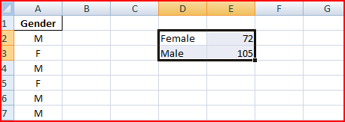
- Then in Excel, go to Insert → Pie → 2-D Pie and click on the first Pie option:

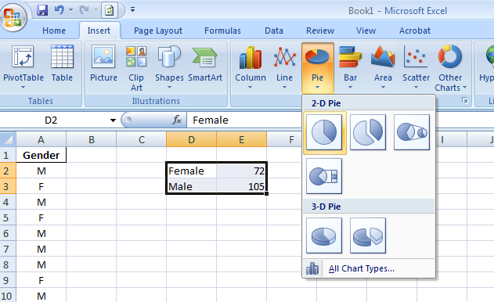

- You should see a pie chart that looks like the one shown below:
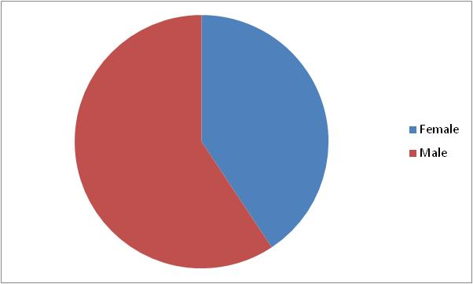

- Then in Excel, go to Layout → Chart Title → Above Chart:

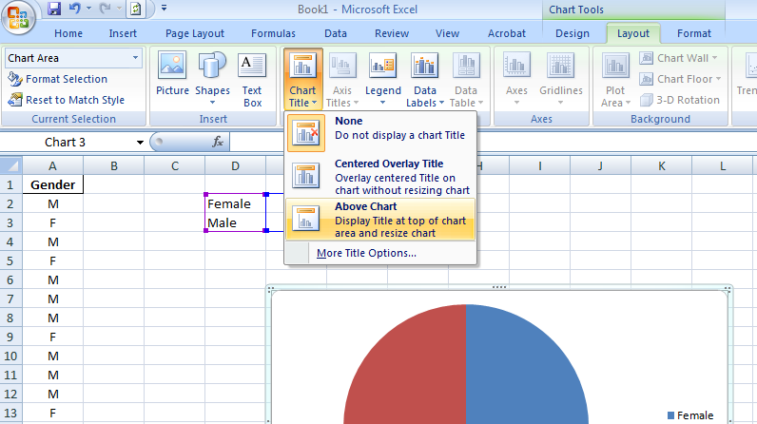

- You will then see a chart with a Generic Title listed above the pie chart as shown below:
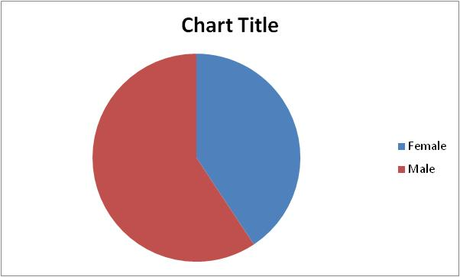

- In the chart title, type in “Percentage of Women and Men in Bro. Cromar’s Class”. Also, if you right click on the pie, select “Add Data Labels”. You should see a pie chart that looks like what is shown below:
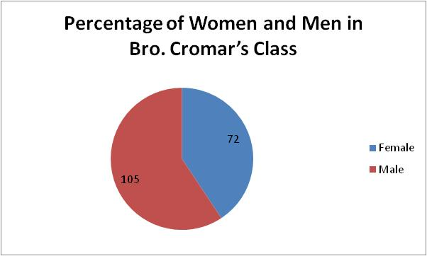

- If you right click on one of the two numbers in the pie you will see a few options listed below. Click on Format Data Labels….
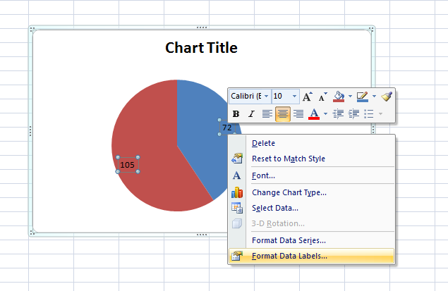

- In the Format Data Labels, Click on Percentages, then click [Close].

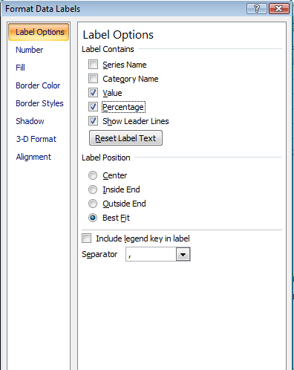

- Your final pie chart should like what is displayed below:

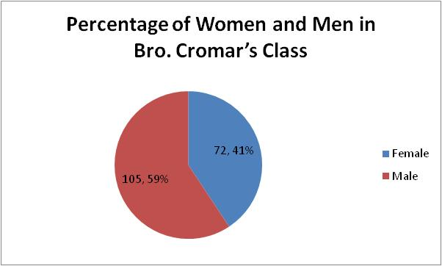

Bar Chart

- Go back to the data you created in the first five steps on the first page. Click and drag where the “Female”, “Male” and count cells are marked. (in this example, cells D2, D3, E2, and E3 are marked)

- Then in Excel, go to Insert → Column → 2-D Column and click on the first Column option:

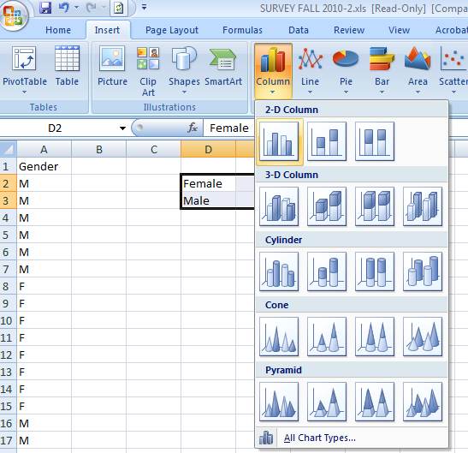

- You should see a bar chart that looks like the one shown below:

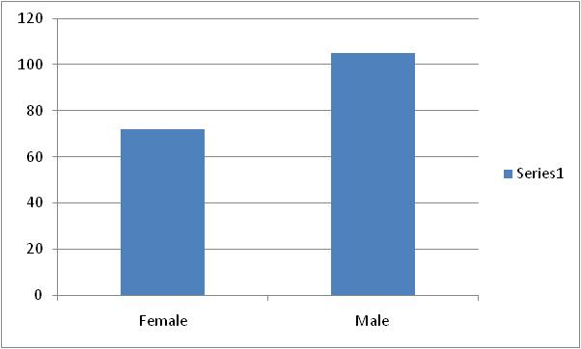

- Then in Excel, go to Layout → Chart Title → Above Chart:

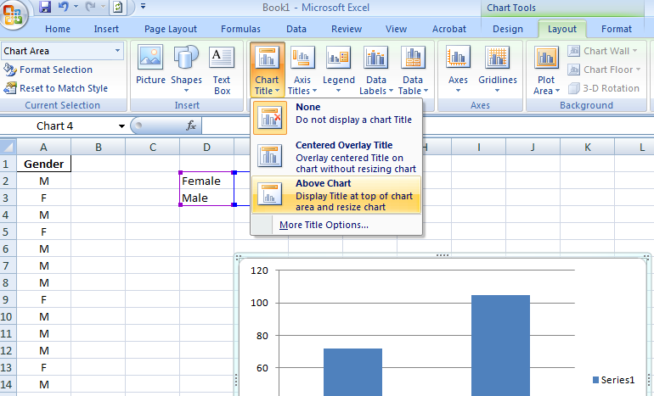

- You will then see a chart with a Generic Title listed above the pie chart as shown below:
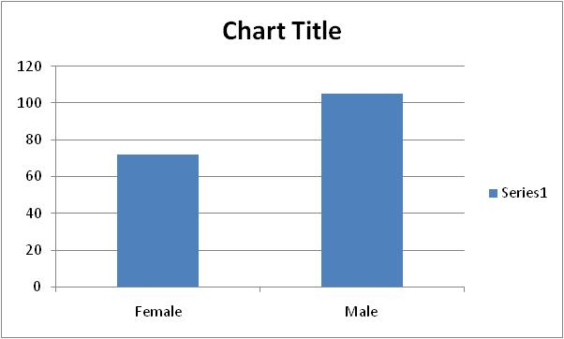

- In the chart title, type in “Percentage of Women and Men in Bro. Cromar’s Class”. Also, if you right click on one of the bars, select “Add Data Labels”. You should see a bar chart that looks like what is shown below:

